SAFE ENTRY PROGRAM

INFORMATION SHEET

WHAT IS IT?

It is a program in which seniors have a lock box installed that holds their house key in case of emergency. The program is offered through collaboration between the Hatfield Police and Fire Departments along with the Hatfield Council on Aging, Northwest District Attorney David E. Sullivan’s Office and the Hampshire County Sheriff’s Department Triad Program.

HOW DOES IT WORK?

A lock box is a small secure box with a combination that holds your house key. It will be installed on the exterior of the home at or near a primary entrance. The location and combination will be on file with the Massachusetts State Police 911 Dispatch Center. When an emergency call comes to the Dispatch Center the dispatcher will inform the responding Police, Fire, and EMS agencies (via a secure format) of the lock box location and combination which will allow them quicker entry to offer assistance if nobody within the home can unlock the door or let them in.

WILL THIS PROGRAM COST ME ANYTHING?

No. The lock box is provided FREE of charge and will be installed by a qualified volunteer.

To receive a lock box fill out and return the Safe Entry Program, Field Interview Form, and the Liability Release to: The Hatfield Police Department, Hatfield Council on Aging or the Hatfield Fire Department, 59 Main Street, Hatfield, MA 01038. (Forms are available at any of these Departments).

After confirmation has been received you will be contacted to set up an installation date.
Please have a working key ready on installation day.

For more information you may contact Sgt. Clint Phillips @ 413-247-0323
or email him at cphillips@hatfieldpolice.com

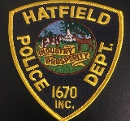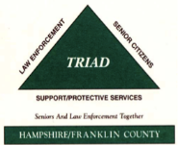
Council on Aging

